
CYPRUS INTERNATIONAL UNIVERSITY

INTERNET PROGRAMMING II

ONLINE APPOINTMENT BOOKING SYSTEM

PROF. JANA ALHAJJ

STUDENT:
NENETTE KANAHU KARUMB - 22121068
KING-MICHAEL ODO- 22205122
NAZAR ÖZBEK- 22208978

SPRING 2025 – 2026

1. Introduction
For this term project, we developed an Online Appointment Booking System using HTML, CSS, JavaScript, PHP, and MySQL. The main objective of this project is to apply the concepts learned in the Internet Programming II course by building a complete web-based application connected to a database.
The system allows users to create an account, sign in, book appointments, view their booked appointments, and cancel an appointment when necessary. This type of system can be used in different real-life situations such as hospitals, beauty salons, consultation centers, and other service-based businesses.
We selected this topic because appointment booking systems are common in many organizations. Instead of managing appointments manually, this system provides a simple online platform where users can manage their appointments more easily. Through this project, we also improved our understanding of frontend development, backend programming, database connection, and user interaction inside a web application.

2. System Features
2.1 User Login:
The system includes a login page where registered users can access their personal account using their email and password. This feature helps protect the system and ensures that only authenticated users can book or view appointments.
2.2 Dashboard:
After signing in, the user is redirected to the dashboard page. The dashboard welcomes the user and provides quick access to the main system functions, such as booking a new appointment or viewing existing appointments.
This page acts as the main navigation area of the system after login.
2.3 Book Appointment:
The booking page allows users to create a new appointment by selecting the appointment type, date, and time. After submitting the form, the appointment information is stored in the database and linked to the logged-in user.
This feature represents the main function of the system because it allows users to reserve appointments directly online.
2.4 View Booked Appointments:
The system also provides a page where users can view all appointments they have booked. The appointments are displayed in a table showing the date, time, reason, status, and action.
This makes it easier for users to track their appointments and manage their schedule.
2.5 Cancel Appointment:
Users can cancel an appointment by clicking the cancel button in the appointments table. Once the appointment is cancelled, the system updates the appointment record in the database.
This feature gives users more flexibility and improves appointment management.

3. Languages and Technologies Used
3.1 Hypertext Markup Language:
HTML was used to create the structure of the web pages. It defines the main elements of the system such as forms, buttons, navigation bars, tables, and page sections.
For example, the login form, booking form, and appointment table were structured using HTML elements.
3.2 Cascading Style Sheets:
CSS was used to design and style the application. It helped create a clean and modern interface using colors, spacing, shadows, buttons, and responsive layouts.
The blue color theme used in the system gives the application a professional appearance and makes the pages visually consistent.
3.3 JavaScript:
JavaScript was used for basic interactivity and form validation. It helps check user input before submitting forms to the server.
For example, JavaScript can be used to make sure that required fields such as email, password, appointment date, and appointment time are not empty.
3.4 Hypertext Preprocessor:
PHP was used as the backend language of the system. It handles important operations such as login, session management, form processing, database connection, appointment booking, and appointment cancellation.
PHP allows the system to communicate with the MySQL database and display dynamic data to users.
3.5 MySQL:
MySQL was used to store the system data. The database stores user account information and appointment records.
Using MySQL allows the application to save, retrieve, update, and manage data efficiently.

3.6 XAMPP:
XAMPP was used as the local development environment. It provides Apache and MySQL services, which are necessary to run the PHP project locally.
The system was tested through localhost using XAMPP.

4. Database Design
The database of the Online Appointment Booking System is developed using MySQL. The main purpose of the database is to store user information and appointment records securely and efficiently.
The project mainly contains two database tables: the users table and the appointments table.

4.1 Table design
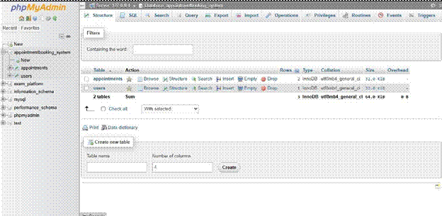
Here we have our appointment and user table

4.1 Users Table
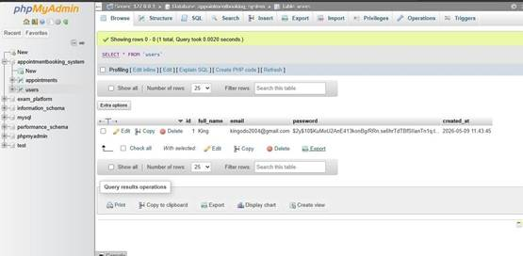
The users table stores all information related to registered users of the system. Each user has a unique identifier which allows the system to distinguish one user from another.
The table contains important fields such as username, email, password, and account creation date.
This table is essential because it allows users to authenticate and access their personal appointment information securely.

4.2 Appointments Table
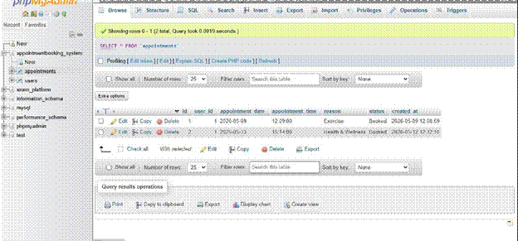
The appointments table stores all booking information created by users inside the system. Each appointment is associated with a specific user through a relationship between the users table and the appointments table.
The table contains information such as appointment date, appointment time, appointment type, and appointment status.
This database structure helps organize appointment records efficiently and allows the system to manage reservations dynamically.

5. Screenshots
The screenshots below show the main pages of the Online Appointment Booking System.
5.1 Sign in Page
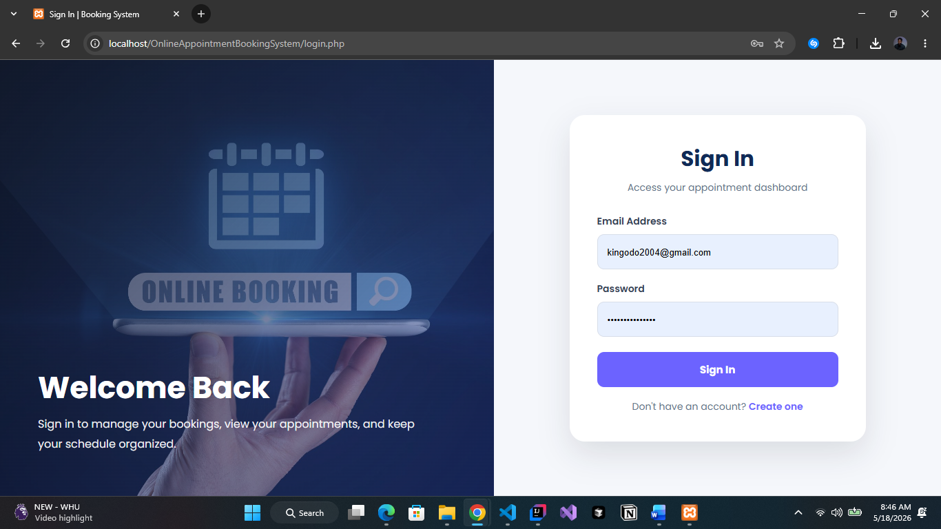
This page allows registered users to sign into the system using their email and password. After successful login, the user is redirected to the dashboard.

5.2 User Dashboard
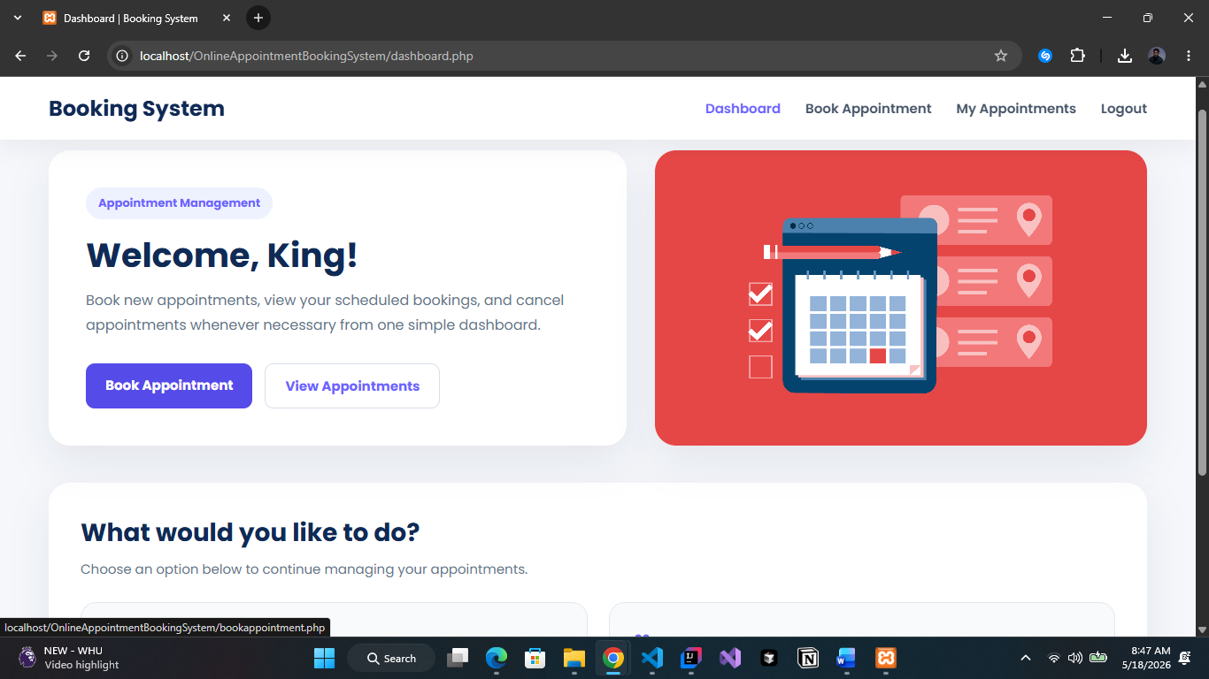
This page appears after the user logs in. It welcomes the user and gives access to the main features of the system, including booking appointments and viewing appointments.

5.3 Book Appointment Page
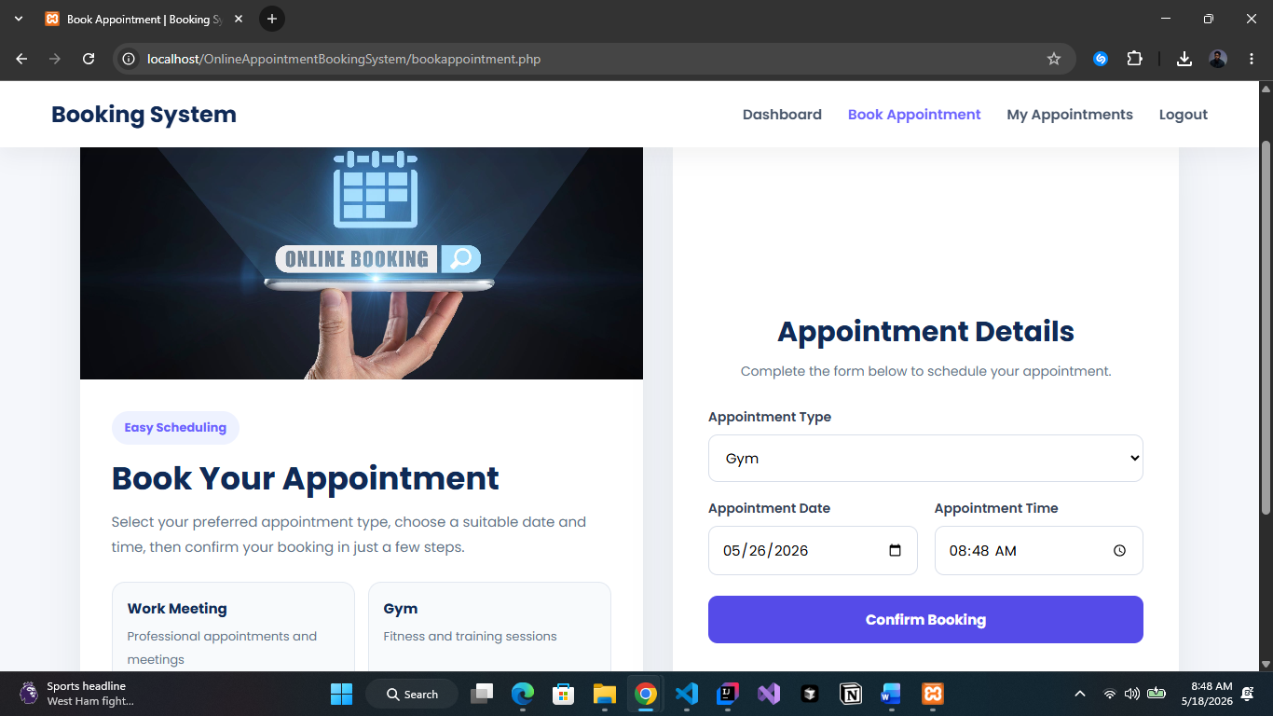
This page allows the user to select the appointment type, date, and time. After filling in the form, the user can confirm the booking.
Insert your third screenshot here.

5.4 View Booked Appointments Page
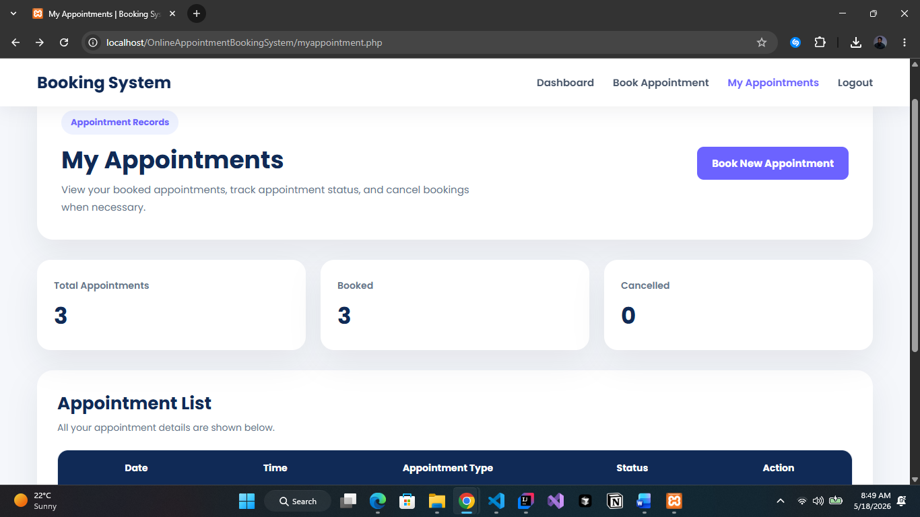
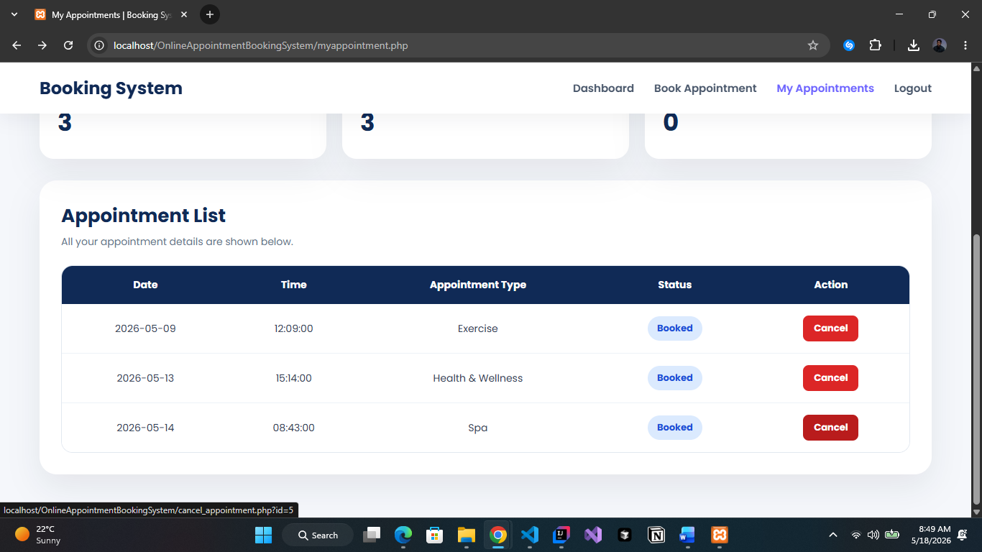
This page displays all appointments booked by the user. The user can see the appointment date, time, reason, status, and cancel an appointment if needed.

6. Conclusion
In conclusion, this project allowed us to develop a complete Online Appointment Booking System using HTML, CSS, JavaScript, PHP, and MySQL. The system allows users to sign in, book appointments, view booked appointments, and cancel appointments.
Through this project, we improved our understanding of web development, database management, PHP backend programming, and user interface design. We also learned how to connect different parts of a web application together in order to create a functional system.
Overall, this project was a useful learning experience because it helped us understand how realworld appointment systems work and how web technologies can be used to solve practical problems.

